
SIMATS ENGINEERING
Saveetha Institute of Medical and Technical Sciences

DEPARTMENT: B.TECH COMPUTER SCIENCE & BIO SCIENCE

COURSE NAME: SOFTWARE ENGINEERING (CSA1008)

ASSIGNMENT TITLE: Case Study Analysis

CASE STUDY TITLE: Case Study 24 – SDG 3: School Nutrition Monitoring System Government

STUDENT NAME: S.NISHITAA

REGISTER NUMBER:192471034

FACULTY NAME:Dr. K.C. SHARMILI

DATE OF SUBMISSION: 24/07/2026

TABLE OF CONTENTS

S.NO | TOPIC | PAGE.NO
1. | Introduction | 7
2. | Problem Identification And Analysis | 7
3. | Solution Design And Implementation | 9
4. | Results And Recommendation | 14
5. | Reflection On Learning And Personal Development | 15
6. | Conclusion | 18
7. | References | 18
8. | Appendices | 19

INTRODUCTION

1.1 Background of the Problem
Government schools play a significant role in promoting the health and well-being of students by providing nutritious meals through school nutrition programs. These programs help reduce hunger, improve students' physical growth, enhance concentration in classrooms, and encourage regular school attendance. However, in many schools, the management of meal distribution, food inventory, student attendance, and nutrition records is still carried out manually using paper-based registers and spreadsheets. This traditional approach is time-consuming, prone to human errors, and makes it difficult for school administrators and government authorities to monitor the effectiveness of the nutrition program. Delays in recording attendance, inaccurate inventory management, and the lack of timely nutrition reports can lead to food shortages, wastage, and inefficient decision-making.
To overcome these challenges, there is a need for a digital School Nutrition Monitoring System that automates the entire process of meal management. The proposed system will enable schools to record student attendance, monitor meal distribution, manage food inventory, and generate nutrition reports through a centralized platform. By digitizing these activities, the system will improve data accuracy, reduce administrative workload, increase transparency, and support better planning and resource allocation.

1.2 Importance of Solving the Problem
A School Nutrition Monitoring System is essential because it helps ensure that every eligible student receives nutritious meals consistently and efficiently. A computerized system minimizes manual errors, saves time, and provides real-time information about attendance, food stock levels, and meal distribution. It enables school administrators and government officials to identify shortages, monitor food quality, and generate reports quickly for informed decision-making. Additionally, the system helps reduce food wastage, improves accountability among staff, and ensures proper utilization of government resources. Ultimately, an efficient nutrition monitoring system contributes to improving students' health, academic performance, and overall well-being.

1.3 Related SDG Goal(s)
The proposed School Nutrition Monitoring System primarily supports Sustainable Development Goal (SDG) 3: Good Health and Well-being, which aims to ensure healthy lives and promote well-being for people of all ages. By monitoring meal distribution, maintaining food quality, and tracking students' nutritional status, the system helps improve children's health and reduce malnutrition. The project also contributes to SDG 2: Zero Hunger by ensuring reliable access to nutritious meals for school children and SDG 4: Quality Education by improving student attendance and learning outcomes through better nutrition.

1.4 Objectives of the Case Study
The primary objective of this case study is to analyze the challenges associated with manual school nutrition management and propose an efficient software engineering solution. The study aims to develop a digital system that automates student attendance, meal distribution, food inventory management, and nutrition reporting. It also seeks to reduce manual paperwork, improve operational efficiency, enhance transparency and accountability, support data-driven decision-making, and ensure effective implementation of school nutrition programs. Furthermore, the proposed system aims to improve the overall health and well-being of students while supporting the achievement of the United Nations Sustainable Development Goals.

PROBLEM IDENTIFICATION AND ANALYSIS

2. Problem Understanding
Government schools play a vital role in providing nutritious meals to students through school nutrition programs to improve their health, reduce hunger, and encourage regular attendance. However, the management of these programs is still largely dependent on manual record-keeping methods, where attendance, meal distribution, food inventory, and nutrition-related information are maintained in paper registers or spreadsheets. This manual approach is time-consuming, labor-intensive, and highly susceptible to human errors, resulting in inaccurate records, duplicate entries, missing information, and delays in updating data. School administrators often find it difficult to monitor whether every eligible student has received a meal, verify the quality and quantity of food distributed, or track the availability of food supplies in real time. In addition, preparing daily, weekly, or monthly reports requires significant effort, leading to delays in submitting information to government authorities. Poor inventory management may cause food shortages, overstocking, or unnecessary wastage, while the absence of proper nutrition monitoring makes it challenging to assess students' health and identify those requiring additional nutritional support. Furthermore, the lack of a centralized digital platform limits transparency, accountability, and effective communication among school staff, administrators, food suppliers, and government officials. These challenges reduce the overall efficiency of the school nutrition program, increase administrative workload, and hinder timely decision-making. Therefore, there is a strong need for an integrated School Nutrition Monitoring System that can automate attendance recording, meal distribution, food inventory management, nutrition tracking, and report generation, ensuring accurate data management, improved operational efficiency, enhanced transparency, and better health outcomes for students.

Objectives
The proposed software aims to:
- Reduce manual work.
- Improve operational efficiency.
- Increase transparency.
- Improve food quality monitoring.
- Track student attendance digitally.
- Manage inventory effectively.
- Generate nutrition reports automatically.
- Improve decision-making.
- Reduce food wastage.
- Enhance user experience.

2.3 Scope
- Student management
- Attendance tracking
- Meal distribution tracking
- Food inventory management
- Nutrition report generation
- User authentication
- Administrator dashboard
- Notifications
- Report generation
- Online payment system
- Hospital management
- Transportation management
- Staff payroll
- Parent financial service

EXISTING SYSTEM ANALYSIS

Existing Process
Currently, schools maintain attendance registers manually. Meal distribution is recorded on paper. Inventory details are updated in notebooks. Nutrition reports are prepared manually at the end of each month and submitted to higher authorities.
Since information is stored separately, administrators spend considerable time preparing reports and verifying records.

Strengths
- Low implementation cost
- Easy to understand
- No technical knowledge required
- Simple paper records

Weaknesses
- Time-consuming
- Human errors
- Duplicate records
- Difficult report generation
- Poor transparency
- Food wastage
- Slow monitoring
- Data loss risk

Gap Analysis
The existing system lacks:
- Digital attendance tracking
- Automated report generation
- Inventory monitoring
- Real-time data
- Nutrition analysis
- Dashboard visualization
- Notifications
- Secure centralized database

PROPOSED SOFTWARE SOLUTION

Proposed System
The proposed School Nutrition Monitoring System is a web-based application that automates meal distribution, attendance recording, food inventory management, nutrition monitoring, and report generation.
The system provides secure login, dashboards, notifications, and centralized data storage.

Functional Modules
- User Registration
- Login
- Student Management
- Attendance Management
- Meal Distribution
- Inventory Management
- Nutrition Monitoring
- Report Generation
- Notification Module
- Admin Dashboard

Functional Requirements
FR1: The system shall allow administrators to log in securely.
FR2: The system shall register students.
FR3: The system shall record student attendance.
FR4: The system shall record meal distribution.
FR5: The system shall manage food inventory.
FR6: The system shall generate nutrition reports.
FR7: The system shall generate attendance reports.
FR8: The system shall send inventory alerts.
FR9: The system shall allow administrators to update food stock.
FR10: The system shall generate monthly reports.

Non-Functional Requirements
- Performance
- Security
- Reliability
- Scalability
- Maintainability
- Availability
- Portability
- Usability

SoftwareEngineeringPrinciplesApplied
    - Modularity—Thesystemisdecomposedintoindependentmodules(attendance,inventory,nutrition, reporting) that can be developed, tested, and updated separately without affecting the whole system.
    - Scalability—Alayered,cloud-hostedarchitectureallowshorizontalscalingtoaccommodategrowthfroma pilot of a few schools to state-wide or nationwide deployment.
    - Reliability—Offline-firstdatacapturewithlocalcachingandautomaticsynchronisationensuresnodatais lost during connectivity interruptions common in rural schools.
    - Security—Role-basedaccesscontrol,encrypteddatatransmission,andauditloggingprotectsensitivestudent and government data from unauthorised access or tampering.
    - Maintainability—Clearseparationofconcerns(presentation,businesslogic,data)andwell-documentedAPIs make it straightforward to fix defects and add new features over time.
    - Reusability—Commonservicessuchasauthentication,notifications,andreportingarebuiltasshared components reusable across all modules and even across other government e-governance systems.
    - Usability—Simple,icon-driveninterfacesandregional-languagesupportensureadoptionbystaffwith varying levels of digital literacy.
    - Flexibility—Configurablenutritionstandards,reportingformats,andworkflowsallowthesystemtoadaptto different states' or regions' specific programme guidelines.

SystemDesign
ThissectionpresentsthekeydesignartefactsthatillustratehowtheSchoolNutritionMonitoringSystemwillfunction, structured,andorganisedatboththeprocessanddatalevels.Diagramswerecreatedtovisuallycommunicatetheuse case interactions, system workflow, layered architecture, and data model.

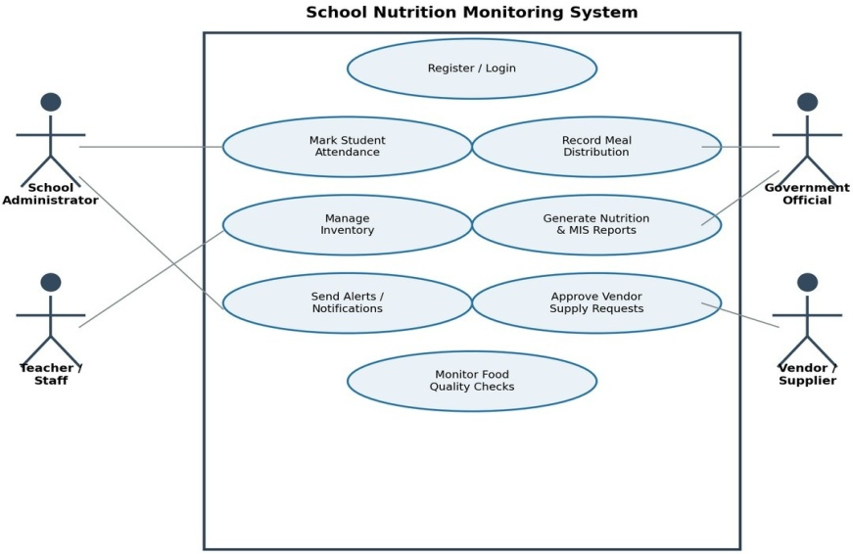
Figure1:UseCaseDiagramoftheSchoolNutritionMonitoring System

The primary actors are the School Administrator, Teacher/Staff, Government Official, and Vendor/Supplier. Administrators and teachers interact with day-to-day operational use cases (attendance, meal recording, inventory), while government officials primarily consume reports and monitor compliance, and vendors respond to supply requests generated by the system.

UseCaseDescription(Sample)

Field | Description
UseCase | RecordMeal Distribution
Actor | Teacher /Kitchen Staff
Precondition | Dailyattendancehasbeen recorded
Main Flow | Staffselectsclass→systemdisplaysexpectedmealcount→staffconfirmsquantity distributed → system updates inventory and logs the record
Postcondition | Mealrecordstored;inventoryautomaticallydeducted;nutritionengineupdated
Exceptions | Ifattendanceisnotyetrecorded,systempromptsstafftocompleteattendancefirst

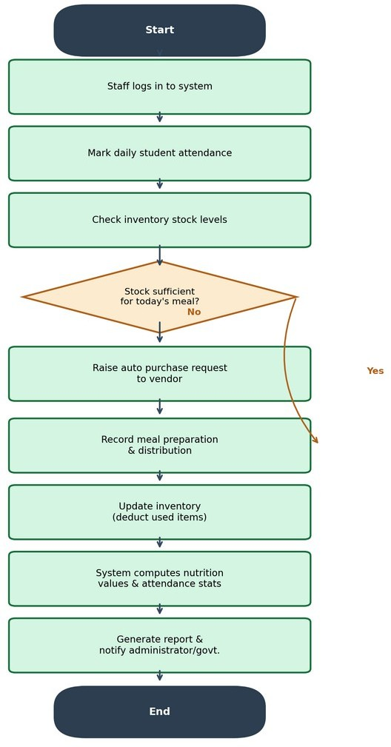
Activity/WorkflowDiagram

Figure2:DailyOperationalWorkflowoftheSNMS

The workflow diagram illustrates the daily operational cycle: staff log in, mark attendance, verify inventory sufficiency,andeitherraiseasupplyrequest(ifstockisinsufficient)orproceeddirectlytorecordingmealdistribution. The system then updates inventory, computes nutrition statistics, and generates reports and notifications for administrators and government stakeholders.

SystemArchitectureDiagram

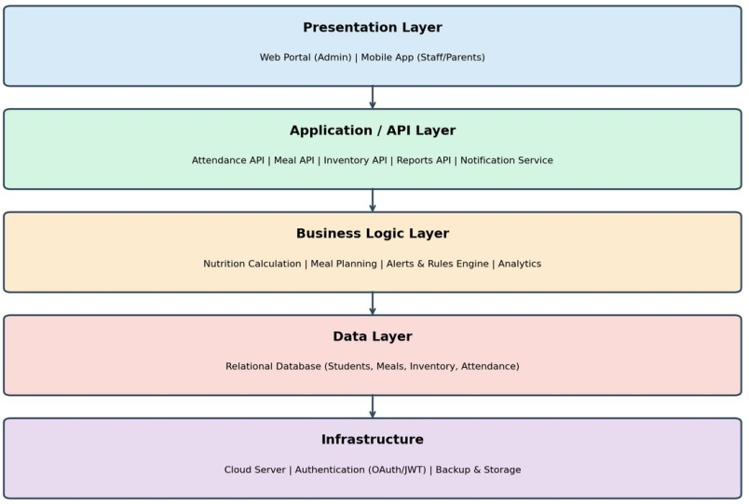

Thearchitecturefollowsaclassiclayereddesign.ThePresentationLayeroffersawebportalforadministratorsanda lightweight mobile app for field staff. The Application/API Layer exposes REST APIs for attendance, meals, inventory,reporting,andnotifications.TheBusinessLogicLayerimplementscorerulessuchasnutritioncalculation and alerting. The Data Layer stores all persistent records in a relational database, while the Infrastructure Layer provides cloud hosting, authentication, and backup services.

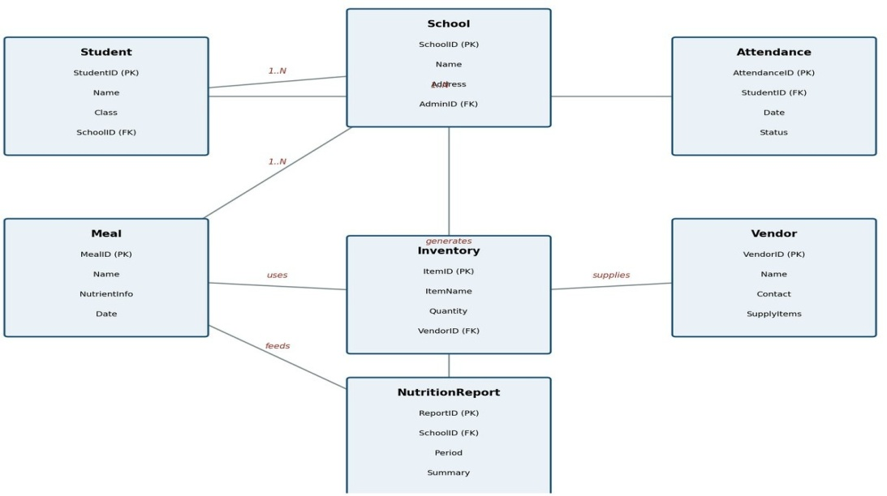
DatabaseERDiagram

Figure4:Entity-RelationshipDiagramoftheSNMS Database

Each School has many Students and generates many Meal and NutritionReport records. Each Student has multiple Attendance entries. Meals draw on Inventory items, which are supplied by Vendors, and School-level activity ultimately feeds into consolidated NutritionReport records used for government monitoring.

Wireframe/UIScreens
RecommendedscreenstobedesignedusingFigmaorCanvafortheimplementationphaseinclude:(1)aLoginscreen with role selection; (2) an Administrator Dashboard summarising today's attendance, meals served, and inventory alerts; (3) an Attendance Entry screen with a simple class-wise checklist; (4) an Inventory Management screen showing stock levels with colour-coded alerts (green/amber/red); (5) a Nutrition Report screen displaying nutrient breakdownoftheday'smenuagainstrecommendedvalues;and(6) Methodology/SDLCSelection

SelectedModel:Agile(Scrum)
TheAgileScrummodelisselectedasthesoftwaredevelopmentlifecyclemethodologyforthisproject.Giventhatthe School Nutrition Monitoring System must serve varied and evolving requirements across different schools, government reporting formats, and connectivity conditions, an iterative and incremental approach is best suited to accommodate ongoing stakeholder feedbac

WhyThisModel?
Scrumallowsthedevelopmentteamtodeliverworkingincrementsofthesystem(forexample,theattendancemodule, followed by the inventory module, followed by the nutrition and reporting modules) every two to three weeks in the form of sprints. This is particularly valuable for a government-facing system where requirements from education departments, nutrition guidelines, and pilot-school feedback are likely to evolve as the system is tested in real conditions.Frequentreviewswithschooladministratorsandgovernmentofficialsduringsprintdemonstrationsensure that the final system genuinely matches ground-level needs rather than only initial assumptions.

AdvantagesofScrumforThisProject
    - Incrementaldeliveryallowsapilotschooltostartusingcoremodules(attendance,meals)beforeadvanced modules (nutrition analytics) are complete.
    - Regularsprintreviewswithrealschooladministratorssurfaceusabilityissuesearly,beforelarge-scalerollout.
    - Changerequests(e.g.,anewgovernmentreportingformat)canbeincorporatedinfuturesprintswithout disrupting the whole project.
    - Cross-functionalScrumteams(developers,testers,UIdesigners)improvecollaborationandreduceintegration risk.

Suitability
Scrumiswellsuitedtothiscasebecausetheproblemdomaincombineswell-understoodcoreoperations(attendance, inventory)withareasthatrequirerefinementbasedonfieldfeedback(nutritionstandards,governmentreportformats, offline synchronisation behaviour). Its short feedback loops reduce the risk of building a system that does not match real school workflows.

DevelopmentStages
    - Sprint0–Requirementgathering,stakeholderinterviews,andbacklogcreation.
    - Sprint1–2–Developmentofuserauthentication,attendance,andbasicdashboardmodules.
    - Sprint3–4–Developmentofmealdistributionandinventorymanagementmodules.
    - Sprint5–Developmentofnutritionanalysisengineandvendorsupply-requestworkflow.
    - Sprint6–Developmentofreporting,analytics,andnotificationmodules.
    - Sprint7–Integrationtesting,useracceptancetesting(UAT),andpilotdeploymentatselectschools.
    - Sprint8–Feedbackincorporation,performancetuning,andfull-scale rollout.

ImplementationPlan
A suggested project timeline of approximately nine weeks for an initial pilot rollout is outlined below. This timeline assumesafocusedScrumteamworkinginparallelacrossdesign,development,andtestingtasks,andcanbeextended proportionally for state-wide or nationwide deployment.

Phase | Duration
RequirementGathering | 1 Week
Design(UI/UX,Architecture,Database) | 1 Week
Development | 3 Weeks
Testing | 1 Week
PilotDeployment | 1 Week

RisksandLimitations
- InternetDependency—Manyruralschoolshaveunreliableornointernetconnectivity,whichcoulddisrupt real-time data synchronisation; mitigated through offline-first design with local caching.
- DataPrivacy—Thesystemstorespersonaldataaboutminors,requiringstrictcompliancewithdataprotection regulations and careful access controls.
- SecurityThreats—Asagovernmentsystemhandlingsensitivedata,itmaybeatargetforcyberattacks, requiring ongoing security audits and monitoring.
- BudgetLimitations—Governmentfundingfortechnologyprocurement,training,andmaintenancemaybe constrained, affecting rollout pace.
- UserAdoption—Staffwithlimiteddigitalliteracymayresistorstrugglewiththetransitionfrompaper-based processes; mitigated through simple UI design and structured training.
- TechnicalChallenges—Ensuringthesystemscalesreliablyacrossthousandsofschoolswithvaryingdevice and network conditions requires careful architectural planning and load testing.

FutureEnhancements
- AIIntegration—Predictivemodelstoforecastinventoryneedsanddetectanomaliesinattendanceormeal patterns.
- Chatbot—Aconversationalassistanttohelpschoolstaffquicklylogdataorqueryreportsviasimple text/voice commands.
- PredictiveAnalytics—Earlywarningsystemsformalnutritionriskbasedonattendance,meal,andgrowth-tracking trends.
- IoTIntegration—Smartkitchenscalesandsensorstoautomaticallycaptureaccuratemealpreparation quantities.
- MobileAppExpansion—Adedicatedparent-facingapptoviewchildattendanceandmeal history.
- Blockchain—Immutable,tamper-proofaudittrailsforhigh-transparencygovernmentreportingandfund utilisation tracking.
- CloudDeploymentatScale—Multi-regionclouddeploymentwithauto-scalingtosupportnationwiderollout.

Conclusion
Governmentschoolnutritionprogrammesplayacriticalroleinsupportingchildhealthandeducationalattendance,yet theyremainhamperedbymanual,fragmentedrecordkeepingthatlimitstransparency,accuracy,andresponsiveness. ThiscasestudyproposedaSchoolNutritionMonitoringSystemthatdigitisesattendancetracking,mealdistribution, inventory management, and nutrition reporting into a single, role-based, cloud-enabled platform. Through modular design, offline-capable data capture, and government-facing analytics dashboards, the proposed solution directly addresses the weaknesses of the existing manual process while remaining scalable to thousands of schools.
By adopting an Agile Scrum development approach, the system can be delivered incrementally, validated with real school stakeholders early, and refined based on field feedback before full-scale deployment. The benefits extend beyondadministrativeefficiency:improvednutritionmonitoringdirectlysupportsthehealthandwell-beingofschool children, contributing meaningfully to Sustainable Development Goal 3 and reinforcing the broader goals of quality education and strong public institutions. Ultimately, this solution represents a practical, technically feasible step toward more transparent, accountable, and effective school nutrition programmes.

References
- WorldHealthOrganization(WHO),"NutritioninSchools,"WHOHealthTopics,who.int.
- UnitedNations,"SustainableDevelopmentGoal3:GoodHealthandWell-Being,"sdgs.un.org.
- UnitedNations,"SustainableDevelopmentGoal2:ZeroHunger,"sdgs.un.org.
- MinistryofEducation,GovernmentofIndia,"PMPOSHAN(Mid-DayMeal)SchemeGuidelines,"pmposhan.education.gov.in.
- Sommerville,I.,"SoftwareEngineering,"10thEdition,PearsonEducation.
- Pressman,R.S.,andMaxim,B.R.,"SoftwareEngineering:APractitioner'sApproach,"9thEdition,McGraw-Hill.
- IEEEXploreDigitalLibrary,"DigitalMonitoringSystemsforPublicWelfareProgrammes,"ieeexplore.ieee.org.
- ACMDigitalLibrary,"DesignofInformationSystemsforGovernmentSchoolProgrammes,"dl.acm.org.
- Springer,"ICTApplicationsforNutritionSurveillanceinSchools,"link.springer.com.
- WorldFoodProgramme(WFP),"SchoolFeedingProgrammes:AGlobalReview,"wfp.org.

